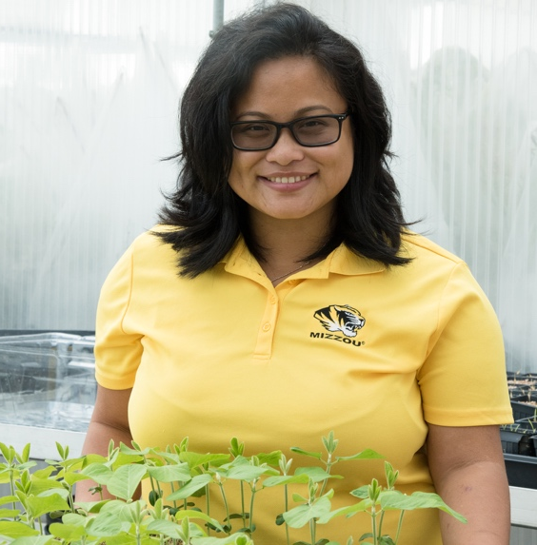
In-Situ Metabolomic Analysis of Setaria viridis Roots Colonized by Beneficial Endophytic Bacteria
Name: Beverly J. Agtuca
Current Position: American Society of Plant Biologists Member Services intern and Conviron Scholars Program teaching assistant; Visiting assistant professor of biology and geosciences at Adams State University, Colorado, United States
Education: PhD in plant, insect & microbial sciences at University of Missouri, Columbia, MO and BSc with honors in biotechnology at State University of New York College of Environmental Science and Forestry (SUNY ESF), Syracuse, NY
Non-scientific Interest: Hiking, traveling, dancing (hip-hop, ballroom, salsa), walking with my two dogs (a Labrador and Shiba inu), and doing outreach
Brief-bio: I was born in Queens, New York, United States and grew up in Holbrook, Long Island, New York. I am currently a visiting assistant professor of biology and geosciences at Adams State University, Colorado, a small liberal arts college and Hispanic Serving Institution. I teach undergraduate courses including cellular biology, microbiology, bioinformatics, general biology, and cell physiology. The research work published in MPMI represents a portion of my PhD work as a graduate research assistant in the Legume-Microbe Interactions Laboratory led by Gary Stacey. During my PhD, my research focused on the symbiotic interaction of nitrogen-fixing bacteria with legumes/non-legumes. I worked on a collaborative research project with other colleagues from George Washington University, Washington, DC and the Environmental Molecular Sciences Laboratory, Richland, WA, United States. Our project focused on identifying unique, metabolic biomarkers associated with nitrogen fixation using Laser Ablation—Electrospray Ionization Mass Spectrometry (LAESI-MS) coupled with the 21 Telsa Fourier Transform Ion Cyclotron Resonance (21 T FTICR) mass spectrometer. There are only two, 21TFTICR-MS instruments and, hence, I was very fortunate to gain access to this resource through our interaction with EMSL. This is a very new technology can measure and image metabolites in fresh, living tissues without the need for fixation. The ultimate goal of my PhD project was to use this technology to sample the metabolic content of single, plant cells. We collaboration was able to reach this goal as described in our other publications. This LAESI-MS and 21 T FTICR method holds tremendous potential for use in further studies of plant-microbe interactions, as well as other biological processes.
Contact me on social media at: LinkedIn and Twitter

